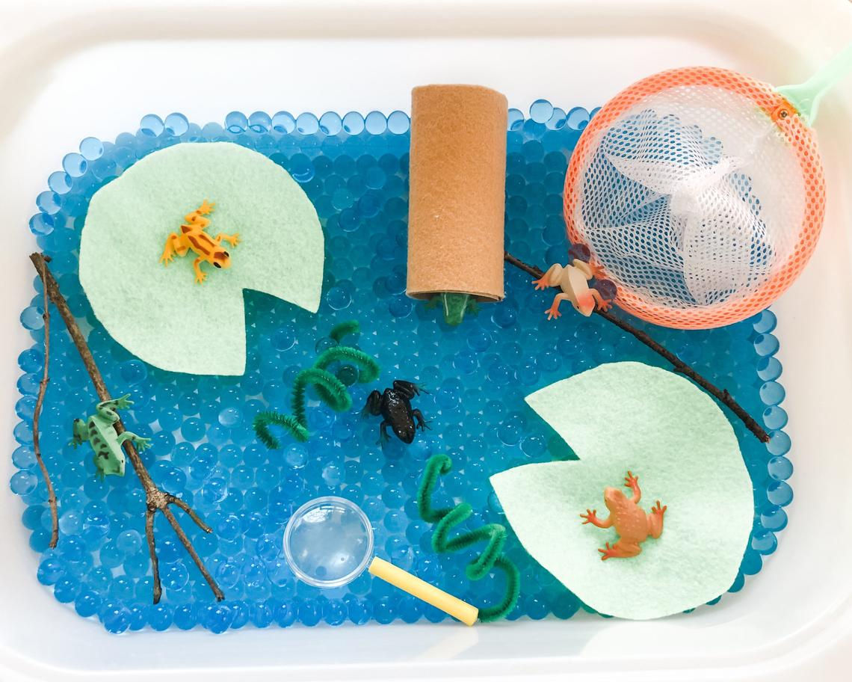Make a frog sensory bin! Water beads can be purchased on Amazon for an affordable price. There are edible water beads that are non-toxic as well! The students use the water beads in class (with hand over hand assistance). If you want to use things you already have at home, try just putting some water in a bin or bucket, use sticks and stones and leaves you can find outside on a walk and let your child feel the different textures in the water !